**Smart Navigation System for Visually Impaired People**



**BTech/III Year CSE/VI Semester**

**19CCSE446/Internet Of Things**

**Case Study Review -1(7/04/2024)**

**Faculty Incharge: Dr.Anantha Narayanan.V**

|  |  |
| --- | --- |
| **Roll_no** | **Name** |
| **CB.EN.U4CSE**21**044** | **Picheri Likitha** |
| **CB.EN.U4CSE**21**046** | **Ragala Tejdeep** |
| **CB.EN.U4CSE**21**056** | **Shri Venkatakrishnan** |

CONTENTS

Project Title…………………………………………………………………………………………………..1

Introduction..………………………………………………………………………………………………..1

Problem Statement…………………………...………………………………………………..1

Problem Description………………………...…………………………………………………1

Importance of Smart Navigation for visually impaired ……..………………….1

Proposed process flow…………………………………………………………………………………..2

SCADA Report…………………………………..……………………………………………………………3

Sensor Placement Diagram..……………..……………………………………………………………4

Important Technicalities involved……..……………………………………………………………5

How we locate user using Bluetooth beacons……………..………………………5

How we store data in database…….……………………………………………………..6

Updating routes continuously………………………………………………………………7

Control Unit Design with Fritzig..…………………………………………………………………..8

Communication technologies & Transmission protocols………………………………..9

Selection of Hardware Components..…………………………….…………………………….11

Key Processes Involved……………………………………………..…………………………………11

Deployment Diagram.…………………..………………………………….………………………….12

Software Flow Chart..…………………… ………………………………….…………………………13

Data Analytics in Cloud..………………..………………………………….…………………………13

UI Screens………………….....………………………………………………….…………………………14

Key Challenges Involved………………………………………………….……………………………15

References………………………………..………………………………….………………………………16

Project Title

Smart Navigation for Visually Impaired People

Introduction

Problem Statement

To design and implement a Smart Navigation System for Visually Impaired People

Problem Description

The Smart Navigation System is designed to assist visually impaired individuals in navigating their surroundings autonomously. Using advanced sensors, it provides real-time feedback on obstacles and routes, enhancing safety and independence for the visually impaired.

Importance of Smart Navigation for visually impaired

* Independence: Smart navigation systems empower visually impaired individuals to travel independently, reducing their reliance on assistance from others. This independence fosters a sense of autonomy and self-confidence.
* Safety: Navigating unfamiliar environments can pose significant safety risks for visually impaired individuals. Smart navigation technologies provide real-time information about obstacles, hazards, and changes in the environment, helping them navigate safely and avoid accidents.

Proposed Process Flow

STEP 1

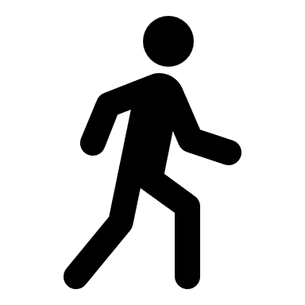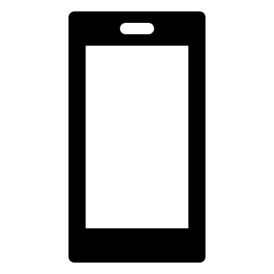

The user gives audio input of destination to the mobile phone

STEP 2



We locate the closest waypoint to the user and query the

database to find stored route

STEP 3



**A->B->C**

We fetch the route begin navigation using audio output

STEP 4

We navigate the user in real-time by locating him at regular

intervals and updating distance to next view point

STEP 5



We perform analysis on cloud to find most used routes

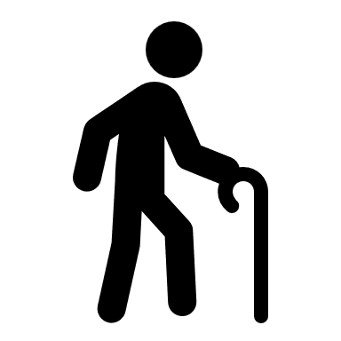

* We also use ultrasonic sensor connected to ESP-32 for

obstacle detection in real time

SCADA Report

Why SCADA?

SCADA (Supervisory Control and Data Acquisition) systems enable centralized monitoring, control, and data acquisition in industries such as energy, manufacturing, and transportation. They allow operators to remotely oversee and manage processes, collect real-time data from sensors, automate tasks, detect faults, analyze historical trends, ensure regulatory compliance, and enhance security.

**Supervisory Control and Data Acquisition**

**1.Data Acquisition:**

BLE beacons collect sensory data, while ultrasonic sensors on ESP32 devices capture additional environmental data to detect obstacles.

RSSI values and ultrasonic sensor readings are digitized for processing.

**2. Networked Data Communication:**

Wi-Fi connectivity on mobile devices and ESP32 devices facilitates communication with the navigation server.

TCP/IP and MQTT protocols are used for reliable data transmission between devices and the server.

**3. Data Presentation:**

Auditory feedback via the mobile device assists visually impaired users in understanding their surroundings.

User-friendly interface on the web app presents analysis such as maximum used routes and routes with maximum obstacles.

**4. Control:**

Automated route guidance based on user location and destination input, with adjustments made in real-time.

Integration with ultrasonic sensors allows for detection of obstacles and hazards along the navigation path.

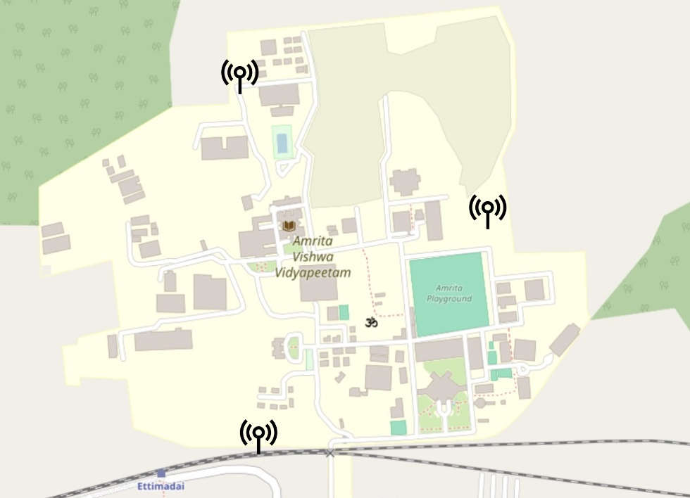Sensor Placement Diagram

Bluetooth beacons strategically placed at key points throughout the campus enable the use of the Triangulation method for locating other devices within the vicinity. By leveraging the signals emitted by these beacons, it becomes possible to determine the approximate location of a device based on its proximity to beacons.

Important Technicalities involved

How we propose to locate the user using signals from Bluetooth beacons

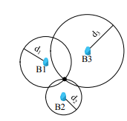

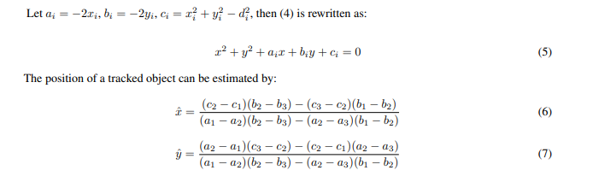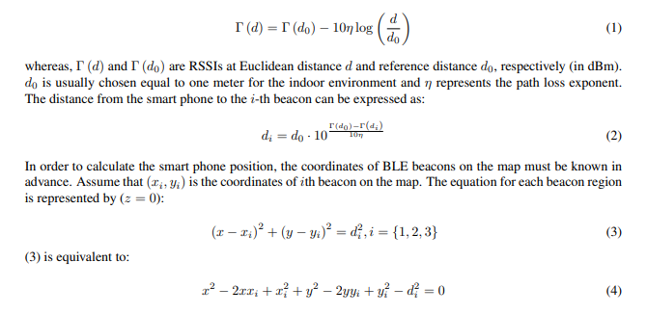

Bluetooth triangulation utilizes signals emitted by multiple Bluetooth beacons to determine an object's position. By measuring the signal strength or time of flight from each beacon, the object's location can be triangulated. This method is employed in indoor positioning systems, asset tracking, and location-based services. It offers precise localization, enabling applications such as navigation in shopping malls, tracking inventory in warehouses, and guiding patients in hospitals. Bluetooth triangulation enhances user experiences by providing accurate location information, improving efficiency, and enabling innovative services in various industries.

How we store data in the database

Consider a building with several floors, corridors, rooms, and exits. We want to create a navigation system to guide a visually impaired person from the building entrance to a specific room on the third floor.

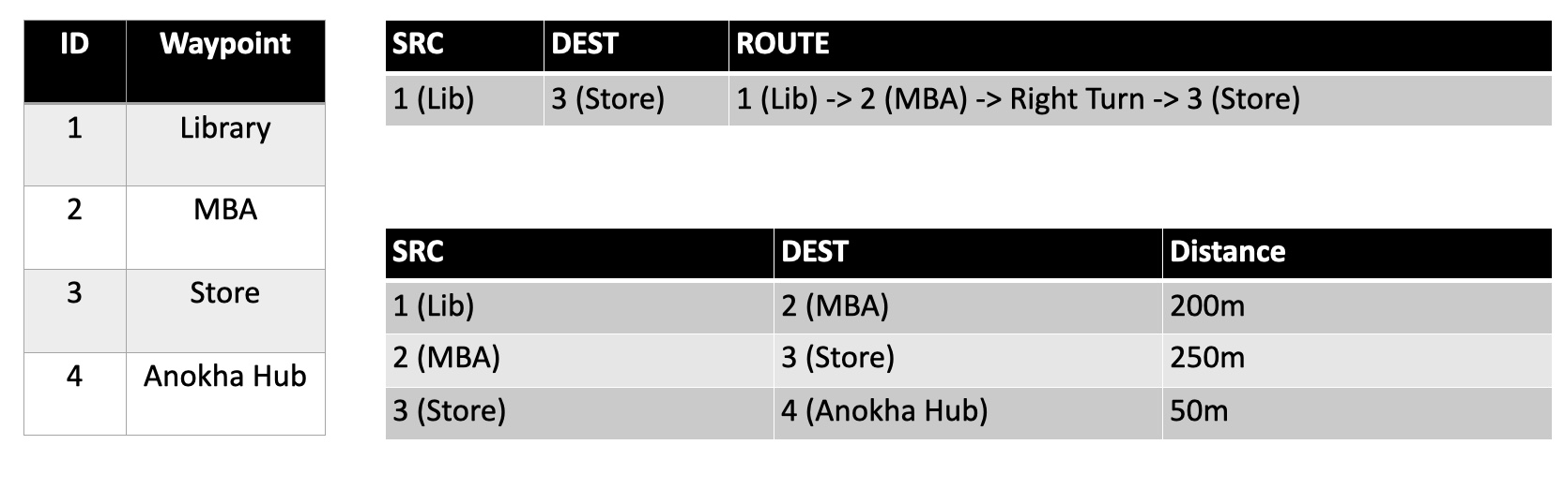

**1. Waypoints:**

Waypoints are specific points of interest along the route. These could be intersections, doorways, staircases, or other notable landmarks.

Each waypoint is identified by a unique ID and associated with its coordinates (latitude and longitude).

Example waypoints in our scenario:

Entrance (ID: 1)

Staircase to Second Floor (ID: 2)

Hallway on Second Floor (ID: 3)

Staircase to Third Floor (ID: 4)

Room 305 (ID: 5)

**2. Route:**

A route is a sequence of waypoints that guides the user from the starting point to the destination.

Each route is identified by a unique ID.

Example route in our scenario:

Route from Entrance to Room 305 (Route ID: 100)

Waypoint Sequence: 1 (Entrance) -> 2 (Staircase to Second Floor) -> 3 (Hallway on Second Floor) -> 4 (Staircase to Third Floor) -> 5 (Room 305)

**3. Connection Table:**

The connection table defines the connections between waypoints, indicating which waypoints are connected to each other and how they are connected (e.g., straight, left turn, right turn).

Each connection is associated with a direction (e.g., North, South, East, West) and a distance.

This table indicates that to go from waypoint 1 (Entrance) to waypoint 2 (Staircase to Second Floor), the user needs to move forward 50 meters. Similarly, to go from waypoint 2 to waypoint 3, they need to move forward 30 meters, and so on.

Updating Routes Continuously

As the user moves through the building and reaches new waypoints, the system continuously updates their current location and calculate the remaining route to the destination. This involves:

* Using Bluetooth beacons to detect the user's proximity to waypoints.
* Updating the user's position on the route based on the detected waypoints.
* Recalculating the remaining route based on the updated position.
* Providing real-time navigation instructions to guide the user along the updated route.

Control Unit Design with Fritzig

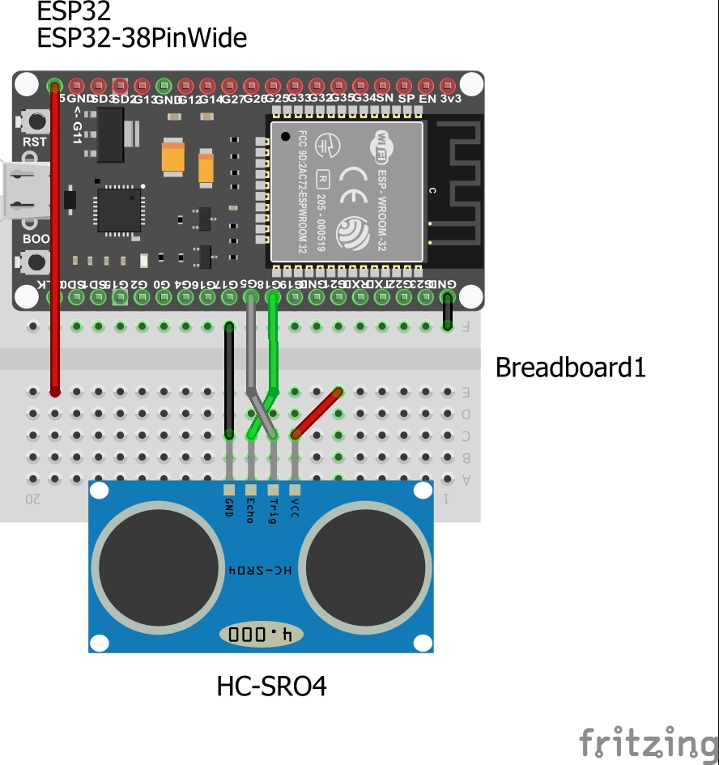

**Ultrasonic sensor**

Communication technologies & Transmission protocols

Wi-Fi connectivity on mobile devices and ESP32 devices facilitates communication with the navigation server.

TCP/IP and MQTT protocols are used for reliable data transmission between devices and the server

Beacons use BLE protocol

TCP:

TCP (Transmission Control Protocol) ensures reliable, connection-oriented communication by breaking data into packets, providing mechanisms for acknowledgment, retransmission, flow control, and congestion control. It supports full-duplex communication and manages connection establishment and termination. TCP's reliability stems from its acknowledgment of received packets, retransmission of lost packets, and sequence numbering to detect missing or out-of-order packets. It dynamically adjusts transmission rates to prevent network congestion and maintains optimal performance. Overall, TCP plays a crucial role in facilitating reliable data transmission over networks, including the internet.

IP:

IP (Internet Protocol) is fundamental to network communication, responsible for routing data packets across networks. IP assigns unique addresses to devices and handles packet forwarding and fragmentation. It operates at the network layer of the OSI model, providing connectionless communication. IP's addressing scheme enables devices to locate each other on the network, facilitating data transmission. It supports various network technologies and topologies, making it scalable and adaptable. IP's key features include addressing, routing, and packet delivery, forming the backbone of internet communication and enabling global connectivity.

MQTT:

MQTT (Message Queuing Telemetry Transport) is a lightweight and efficient messaging protocol designed for IoT (Internet of Things) and M2M (Machine to Machine) communication. It facilitates real-time data exchange between devices and applications, utilizing a publish-subscribe messaging pattern. In MQTT, clients publish messages to a broker, which then distributes these messages to interested subscribers. This decoupled architecture allows for scalable and flexible communication, with minimal overhead. MQTT operates over TCP/IP and is characterized by its low bandwidth and resource requirements, making it suitable for constrained environments. Its features include Quality of Service (QoS) levels for message delivery assurance, MQTT's simplicity, reliability, and support for various platforms make it a preferred choice for IoT and M2M applications.

BLE:

BLE (Bluetooth Low Energy) is a wireless communication protocol designed for low-power devices, commonly used in IoT, wearables, and smart home applications. It enables energy-efficient data exchange between devices, allowing for extended battery life. BLE operates in a star or mesh network topology, where one central device communicates with multiple peripheral devices. It supports two modes of operation: advertising, where devices broadcast their presence, and connection, where devices establish a bi-directional link for data exchange. BLE utilizes GATT (Generic Attribute Profile) to define data structures and services, enabling standardized communication between devices. Its features include low latency, high throughput, and support for various data transfer modes. BLE's compatibility with smartphones and widespread adoption in consumer electronics make it a popular choice for wireless connectivity in IoT ecosystems.

Selection of Hardware components

* Ultrasonic Sensor
* Bluetooth beacon
* ESP 32
* Mobile Phone

Ultrasonic Sensor

Detecting Obstacles and providing real-time feedback on their surroundings.

Bluetooth beacon

Transmits signals to smartphones, enabling precise location tracking and guidance through indoor environments

ESP 32

It incorporates sensors and wireless capabilities, facilitating the processing of environmental data and providing timely guidance and feedback for effective navigation

Mobile Phone

It acts like actuators as well, providing haptic feedback and audible alerts to guide visually impaired individuals through a smart navigation system, enhancing their spatial awareness and safety.

Key Process Involved

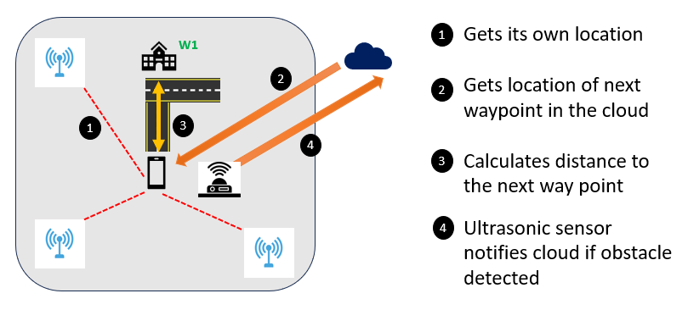

Deployment level Diagram

* Our level-3 IoT system has a single node.
* Data is stored and analyzed in the cloud and application is cloud- based

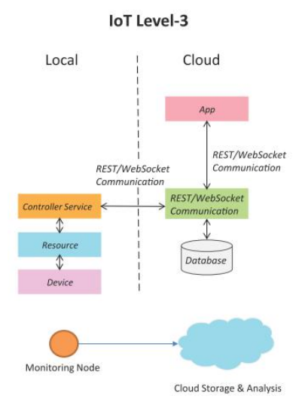

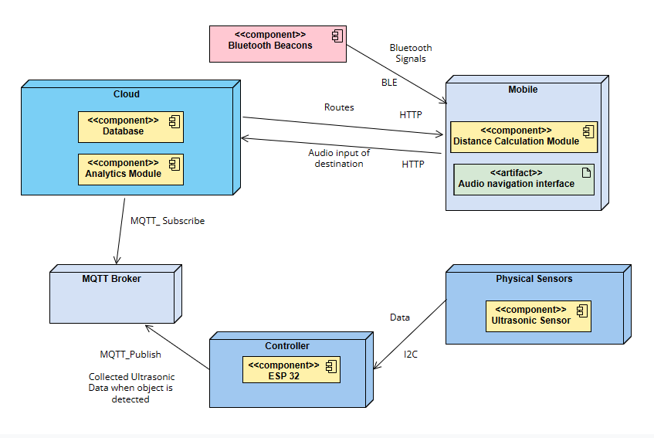

Flowchart of the software process

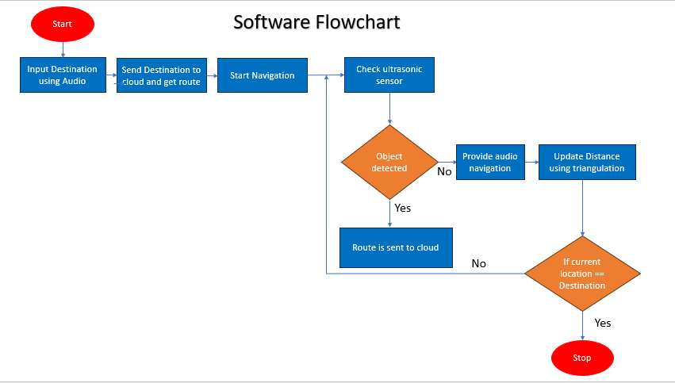

Data Analytics in Cloud

We prefer cloud over edge as response time isn’t an important factor for updating the stats and showing the analysis on the website. As far as the user is concerned all operations take place within the mobile. This increases the speed by a significant amount and proves to be very efficient especially for our use case.   
  
We use the cloud to mainly perform two kinds of analysis and show the same in our website  
  
1. Every time a particular route is being queried; we increase the count of that route by one. In the end we will have a list of routes with the number of times they were queried. This will help in analysis such as determining the route with maximum traffic.

2. Every time the ultrasonic sensor detects an obstacle, we update the same in the cloud and this in turn will help determine the route which has had the most obstacles in the past.

UI Screens

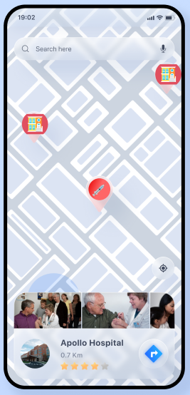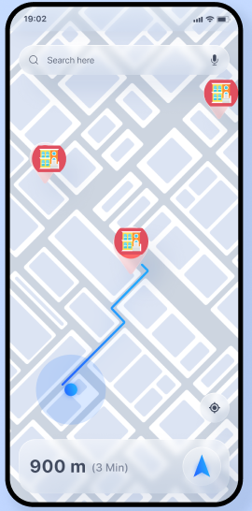

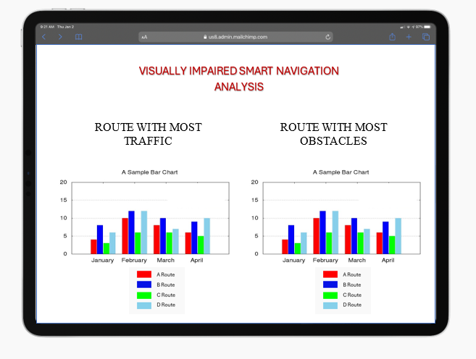

Key challenges Involved

* When we perform position triangulation using beacons, we get around +- 2 meters accuracy of location if the smartphone is within 6 meters range of 2-3 beacons. That means a lot of beacons, which in some environments is not possible and the measurement isn’t really that precise [1]

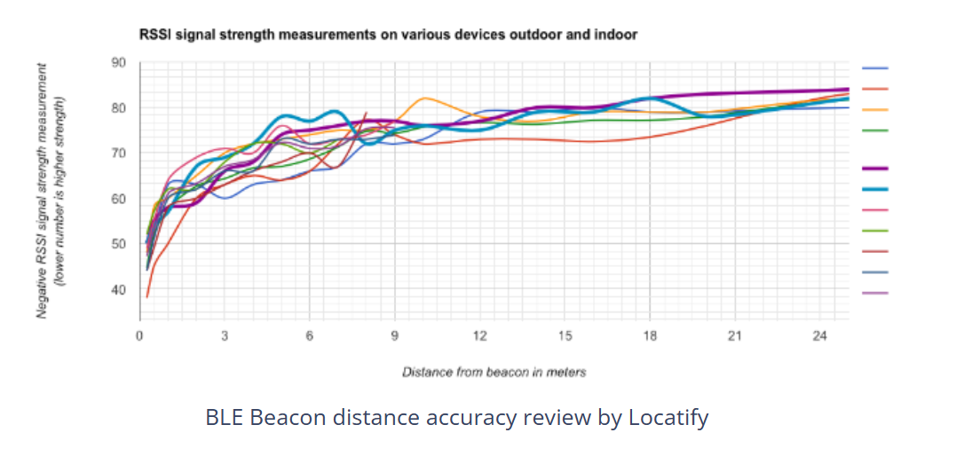

* May not be the most cost-efficient solution given the number of beacons that need to deployed for achieving good accuracy
* 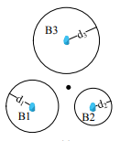The edge case of user not in intersection of 3 beacon regions

References

[1] [BLE Beacons for Indoor positioning : No Bull, Beacon review | Locatify](https://locatify.com/blog/ble-beacons-no-bull-beacon-review/#:~:text=When%20we%20perform%20position%20triangulation,isn%27t%20really%20that%20precise.)

[2] <https://www.beaconzone.co.uk/blog/using-multi-bluetooth-ibeacon-trilateration-for-increased-accuracy/>

[3] <https://www.sciencedirect.com/science/article/pii/S1532046419302072>

[4] <https://www.researchgate.net/profile/Naveenbalaji-Gowthaman/publication/315458948_GPS_Based_Smart_Navigation_for_Visually_Impaired_Using_Bluetooth_30/links/58d0f2b24585158476f35d88/GPS-Based-Smart-Navigation-for-Visually-Impaired-Using-Bluetooth-30.pdf>